**WATER SAVER USING MICROCONTROLLER**

**PROJECT REPORT**

Submitted for CBCS in B.Tech –CSE (CORE) for

**BECE204L – Microprocessors and Microcontrollers**

By

**HRITHIK KUMARAN (22BCE1002)**

**RONAK (22BCE1032)**

**SHAHISHNU JR (22BCE1046)**

**SATVIK.V (22BCE1207)**

**Slot: E1+TE1**

**Name of faculty**: **Dr. A. Sivasubramanian**

**SCHOOL OF COMPUTER SCIENCE AND ENGINEERING**

|  |  |  |  |  |
| --- | --- | --- | --- | --- |
| **CH. NO** |  |  | **TOPIC** | **PAGE NO.** |
|  |  |  | INTRODUCTION | **3** |
| 1 |  |  | LITERATURE SURVEY | **3** |
| 2 |  |  | DESIGN AND SIMULATION | **7** |
| 3 |  |  | SOFTWARE ANALYSIS | **8** |
| 5 |  |  | HARDWARE ANALYSIS | **11** |
| 8 |  |  | CONCLUSION AND FUTURE SCOPE | **29** |
| 9 |  |  | BIBLIOGRAPHY | **15** |
| 10 |  |  | ACKNOWLEGDEMENT | **16** |
| 11 |  |  | ABSTRACT | **17** |

**TABLE OF CONTENTS:**

**CHAPTER 1**

**INTRODUCTION**

Water is a universal solvent which plays an important role in everyday life. The total amount of water available on earth has been estimated at 1.4 billion cubic kilometers. About 95% of the Earths water is unfit for human consumption. About 4% is locked in the polar ice caps, and the rest 1% constitutes all fresh water found in rivers, streams and lakes which is suitable for our consumption. A study estimated that a person in India consumes an average of 135 liters per day. This consumption would rise by 40% by the year 2025. This signifies the need to preserve our fresh water resources.

Many houses make use of supplementary water tank to store water that is collected from rain water or water pumped from well or underground. At present, water meters are used to calculate the amount of water used at homes. This doesn’t provide an efficient method of monitoring the water usage. The water is wasted at each and every outlet knowingly or unknowingly which adds up to huge amount in the end. Efficient management of the water used at homes is very much necessary as, about 50% of water supplied to the cities gets wasted through its improper usage. Water management is only possible, if the user is aware of the quantity of water he uses and the quantity available to him.

Hence there is a need for modifying the traditional water meters for the users to continuously monitor their water usage which is always not possible. At present, water meters are used to calculate the amount of water used at homes. This doesn’t provide an efficient method of monitoring the water usage.

**1.1 Why we made this project ?**

Water Conservation: By automatically shutting off the water supply when the tank is full, the system helps prevent overflows. This contributes to water conservation by avoiding wastage, especially in regions where water is scarce or during times of drought.

Cost Savings: For households or businesses that pay for water usage, preventing overflows can lead to cost savings. It helps individuals and organizations use water more efficiently, reducing their water bills.

Environmental Impact: Efficient water use is essential for environmental sustainability. By preventing unnecessary water wastage, your project contributes to the overall goal of conserving natural resources and reducing environmental impact.

Automation for Convenience: The automated nature of your water level indicator adds a level of convenience for users. They don't have to constantly monitor the water level or manually control the water supply, making it easier for individuals to manage their water usage.

Preventing Water Damage: Overflowing water can lead to water damage in homes or buildings. By automatically turning off the water when the tank is full, your project helps prevent potential property damage, saving individuals and communities from the costs and hassles associated with such incidents.

Promoting Awareness: Your project can also be part of a broader educational initiative to raise awareness about water conservation. By showcasing the importance of monitoring and controlling water levels, you contribute to a culture of responsible water use.

Scalability: The water level indicator system can be adapted for use in various settings, from individual homes to larger industrial or agricultural applications. This scalability enhances the potential positive impact on water conservation and efficiency across different sectors of society.

Learning Experience: Beyond the societal benefits, working on such a project provides a valuable learning experience for those involved. It combines principles from electronics, programming, and environmental science, fostering skills and knowledge that can be applied in various contexts.

**1.3Key Components:**

Water Level Sensors: Utilize sensors to measure the water level in the tank accurately. The choice of sensors may include ultrasonic sensors, float switches, or other appropriate technologies.

Microcontroller Unit (MCU): Employ a microcontroller to process sensor data and control the water supply. Commonly used microcontrollers for this type of project include Arduino or Raspberry Pi.

Actuators/Relays: Connect actuators or relays to the microcontroller to control the water flow. These components enable the system to automatically turn off the water supply when the tank is full.

User Interface: Integrate a user interface to provide feedback to users about the system status. This could include LED indicators, an LCD display, or even a mobile app for remote monitoring.

**1.3.1Functionality:**

Water Level Monitoring: The system continuously monitors the water level in the tank using the sensors, providing real-time data to the microcontroller.

Automatic Shut-Off: When the water level reaches a predefined threshold indicating a full tank, the microcontroller triggers the actuators or relays to shut off the water supply.

User Alerts: Implement a user interface to alert users about the system status, ensuring transparency and user awareness.

Override Capability: Include a manual override option to allow users to control the water supply manually if needed.

**1.3.2Applications:**

Residential Water Tanks: Suitable for homes and apartments with water storage tanks.

Commercial/Industrial Applications: Scalable for use in larger water storage systems, such as those in commercial or industrial settings.

Agricultural Water Management: Applicable for agricultural purposes to control irrigation systems.

Educational Aspects:

This module provides an opportunity for participants to enhance their skills in electronics, programming, and system integration. It fosters an understanding of water conservation principles and the application of technology for societal and environmental benefits.

Prerequisites:

Basic knowledge of electronics, microcontrollers, and programming concepts is recommended. Familiarity with Arduino or Raspberry Pi platforms is advantageous but not mandatory.

Assessment:

Participants will be assessed based on the functionality of their water level indicator system, the accuracy of water level measurements, and the effectiveness of the automatic shut-off mechanism. Additionally, documentation and a presentation on the societal and environmental impact of the project will be required

**1.3.3 COST OF THE PROJECT**

**8051 Board - ₹1600/-:**

This component refers to the development board based on the 8051 microcontroller. The 8051 microcontroller is a popular choice for embedded systems projects. The board typically includes the microcontroller, power supply circuitry, and often other components for ease of use in prototyping.

**Transistors, Resistor & Wires - ₹20/-:**

Transistors and resistors are basic electronic components used for various purposes in electronic circuits. Wires are essential for connecting components on the breadboard or circuit board. ₹20/- is a minimal cost estimate for these fundamental components.

**Relay Board - ₹50/-:**

The relay board is a module containing one or more relays. Relays are electromagnetic switches that can be controlled by a low-voltage signal, allowing them to control higher-voltage devices. In this project, a relay board is likely used to control the water supply based on the water level. ₹50/- is a reasonable estimate for a basic relay board.

**LCD 16x2 - ₹150/-:**

The 16x2 LCD display is used as a user interface to provide information about the water level or system status. This component is useful for creating a visual display for users. ₹150/- is a common price for a standard 16x2 LCD module.

**Breadboard - ₹100/-:**

A breadboard is a crucial tool for prototyping electronic circuits. It allows you to connect and disconnect components quickly during the development phase, making it easier to experiment with different circuit configurations. ₹100/- is a reasonable cost for a standard-sized breadboard.

**Total - ₹1900/-:**

The total cost of ₹1900/- covers the expenses for all the mentioned components.

**1.4ADVANTAGE AND DISADVANTAGE**

**Advantages:**

Water Conservation: The primary advantage is the conservation of water. By automatically shutting off the water supply when the tank is full, the system prevents wastage and contributes to efficient water use.

Cost Savings: Users benefit from reduced water bills due to the prevention of overflows. This can be particularly advantageous for households and businesses that pay for water usage.

Environmental Impact: The project supports environmental sustainability by reducing unnecessary water consumption, helping to preserve this valuable resource.

Convenience: The automated nature of the system adds convenience for users, as they don't have to manually control the water supply or worry about constantly monitoring the water level.

Property Protection: The system helps prevent water damage to homes or buildings by avoiding overflows, potentially saving individuals and communities from the costs and inconvenience associated with such damage.

Scalability: The project can be adapted for use in various settings, from individual households to larger industrial or agricultural applications, enhancing its versatility and positive impact.

Education and Awareness: The project can serve as an educational tool to raise awareness about responsible water use and conservation, promoting a culture of environmental consciousness.

**Disadvantages:**

Initial Cost: Implementing the water level indicator system may require an initial investment in hardware, sensors, and possibly microcontrollers or other electronic components, which could be a barrier for some users.

Maintenance: Like any electronic system, regular maintenance may be required to ensure proper functioning. This could include checking sensors, cleaning components, and addressing any technical issues that may arise.

Dependency on Electricity: If the system relies on electricity, power outages could temporarily disable the water level indicator, potentially leading to overflow during that time.

Technical Complexity: Depending on the complexity of the system, users might need some technical knowledge to set up and troubleshoot the water level indicator. This could be a limitation for individuals who are not familiar with electronics or programming.

False Readings: External factors such as sensor malfunction, debris in the tank, or sensor calibration issues could lead to false readings, potentially causing the system to shut off water prematurely or fail to do so when needed.

Limited Applicability: The project might not be suitable for all types of water storage systems or environments, limiting its applicability in certain contexts.

**Module Overview**:

This module focuses on the development of an Automatic Water Level Indicator, designed to efficiently manage water usage by automatically controlling the water supply when the tank reaches its capacity. The project aims to contribute to water conservation, cost savings, and environmental sustainability.

**CHAPTER 2**

**LITERATURE SURVEY:**

1. "Design and Implementation of Water Level Indicator Using 8051 Microcontroller" by S. S. Rakhonde and S. S. Agnihotri (2012):

This paper discusses the design and implementation of a water level indicator using the 8051 microcontroller. The authors present a detailed circuit description, including sensor interfacing and the programming of the 8051 microcontroller for water level monitoring.

1. "Microcontroller-Based Water Level Controller" by M. S. Kumar and S. N. Amma (2014):

This work focuses on the development of a water level controller based on the 8051 microcontroller. The paper provides insights into the circuit design, sensor calibration, and the programming of the microcontroller for water level control.

1. Automatic Water Level Detector and Controller Using 8051 Microcontroller; Patel et al. (2021):

This study presents the design and implementation of an automatic water level detector and controller using an 8051 microcontroller. The system uses floating transducers to detect the water level in the tank and controls the water pump accordingly. The authors discuss the system's hardware and software components and present test results to confirm the system's functionality.

1. "Design and Implementation of Microcontroller Based Water Level Controller" by S. M. Ali, S. M. Deshmukh, and N. G. Jadhav (2016):

This paper presents the design and implementation of a water level controller based on the 8051 microcontroller. It includes discussions on the selection of sensors, interfacing with the microcontroller, and the programming logic for efficient water level monitoring and control.

1. "Development of Water Level Monitoring System using 8051 Microcontroller" by S. S. Rakhonde and S. S. Agnihotri (2018):

Another work by the same authors as the first reference, this paper might provide further insights or updates on their earlier work. It could include improvements, additional features, or experimental results based on the continued development of water level monitoring systems.

1. "Real-Time Water Level Monitoring System Using GSM Module and 8051 Microcontroller" by R. K. Saini and N. P. Garg (2020):

This paper explores the integration of GSM (Global System for Mobile Communications) technology with an 8051 microcontroller for real-time water level monitoring. It discusses the advantages of remote monitoring and control using mobile communication.

**CHAPTER 3**

**DESIGN AND SIMULATION:**

**BLOCK DIAGRAM:**

**SIMULATION :**

**SOFTWARE ANALYSIS:**

ORG 0000H

CLR P3.0 ;Relay

CLR P1.0 ;Full

CLR P1.1 ;Half

CLR P1.2 ;Empty

ACALL INITIAL

ACALL HEAD

EMPTY: JNB P1.2,EMPTY

SETB P3.0

ACALL DELAY ; give LCD some time

MOV A, #69 ; display letter E

ACALL DATAWRT ; call display subroutine

ACALL DELAY ; give LCD some time

MOV A, #77 ; display letter M

ACALL DATAWRT ; call display subroutine

ACALL DELAY ; give LCD some time

MOV A, #84 ; display letter T

ACALL DATAWRT ; call display subroutine

ACALL DELAY ; give LCD some time

MOV A, #89 ; display letter Y

ACALL DATAWRT ; call display subroutine

ACALL DELAY

MOV A, #' '

ACALL DATAWRT ; call display subroutine

ACALL DELAY

MOV A,#'M'

ACALL DATAWRT ; call display subroutine

ACALL DELAY

MOV A,#'1'

ACALL DATAWRT

ACALL DELAY

HALF: JNB P1.1,HALF;

ACALL DELAY ; give LCD some time

MOV A, #72 ; display letter H

ACALL DATAWRT ; call display subroutine

ACALL DELAY ; give LCD some time

MOV A, #65 ; display letter A

ACALL DATAWRT ; call display subroutine

ACALL DELAY ; give LCD some time

MOV A, #76 ; display letter L

ACALL DATAWRT ; call display subroutine

ACALL DELAY ; give LCD some time

MOV A, #70 ; display letter F

ACALL DATAWRT ; call display subroutine

ACALL DELAY ; give LCD some time

MOV A, #' '

ACALL DATAWRT ; call display subroutine

ACALL DELAY

JNB P3.0,MOTOROFF

MOV A,#'M'

ACALL DATAWRT ; call display subroutine

ACALL DELAY

MOV A,#'1'

ACALL DATAWRT

ACALL DELAY

SJMP FULL

MOTOROFF: MOV A,#'M'

ACALL DATAWRT ; call display subroutine

ACALL DELAY

MOV A,#'0'

ACALL DATAWRT

ACALL DELAY

SJMP EMPTY

FULL: JNB P1.0,FULL;

CLR P3.0 ;restricting the current flow

ACALL DELAY ; give LCD some time

MOV A, #70 ; display letter F

ACALL DATAWRT ; call display subroutine

ACALL DELAY ; give LCD some time

MOV A, #85 ; display letter U

ACALL DATAWRT ; call display subroutine

ACALL DELAY ; give LCD some time

MOV A, #76 ; display letter L

ACALL DATAWRT ; call display subroutine

ACALL DELAY ; give LCD some time

MOV A, #76 ; display letter L

ACALL DATAWRT ; call display subroutine

ACALL DELAY ; give LCD some time

MOV A, #' '

ACALL DATAWRT ; call display subroutine

ACALL DELAY

MOV A,#'M'

ACALL DATAWRT ; call display subroutine

ACALL DELAY

MOV A,#'0'

ACALL DATAWRT

ACALL DELAY

COMNWRT: ; send command to LCD

MOV P0 , A ; copy reg A to port 1

CLR P2.7 ; RS=0 for command

CLR P2.6 ; R/W’=0 for write

SETB P2.5 ; E=1 for high pulse

ACALL DELAY ; give LCD some time

CLR P2.5 ; E=0 for H-to-L pulse

RET

DATAWRT: ; write data to LCD

MOV P0, A ; copy reg A to port 1

SETB P2.7 ; RS=1 for data

CLR P2.6 ; R/W=0 for write

SETB P2.5 ; E=1 for high pulse

ACALL DELAY ; give LCD some time

CLR P2.5 ; E=0 for H-to-L pulse

RET

HEAD:

MOV A,#'W'

ACALL DATAWRT

ACALL DELAY ; give LCD some time

MOV A,#'A'

ACALL DATAWRT

ACALL DELAY ; give LCD some time

MOV A,#'T'

ACALL DATAWRT

ACALL DELAY ; give LCD some time

MOV A,#'E'

ACALL INITIAL ; starting point command

ACALL DELAY ; give LCD some time

MOV A,#'R'

ACALL DATAWRT

ACALL DELAY ; give LCD some time

MOV A,#'L'

ACALL DATAWRT

ACALL DELAY ; give LCD some time

MOV A,#'V'

ACALL DATAWRT

ACALL DELAY ; give LCD some time

MOV A,#'L'

ACALL DATAWRT

ACALL DELAY ; give LCD some time

MOV A,#':'

ACALL DATAWRT

ACALL DELAY ; give LCD some time

RET

DELAY: MOV R3, #50 ; 50 or higher for fast CPUs

HERE2: MOV R4, #255 ; R4 = 255

HERE: DJNZ R4, HERE ; stay until R4 becomes 0

DJNZ R3, HERE2 ; stay until R3 becomes 0

RET

INITIAL: ;starting point command

MOV A, #38H ; INITIALIZE 2x16 LCD

ACALL COMNWRT ; call command subroutine

ACALL DELAY ; give LCD some time

MOV A, #0EH ; display on, cursor on

ACALL COMNWRT ; call command subroutine

ACALL DELAY ; give LCD some time

MOV A, #01 ; clear LCD

ACALL COMNWRT ; call command subroutine

ACALL DELAY ; give LCD some time

MOV A, #06H ; shift cursor right

ACALL COMNWRT ; call command subroutine

ACALL DELAY ; give LCD some time

MOV A, #80H ; cursor at line 1, pos. 4

ACALL COMNWRT ; call command subroutine

RET

END

**SCREENSHOTS:**

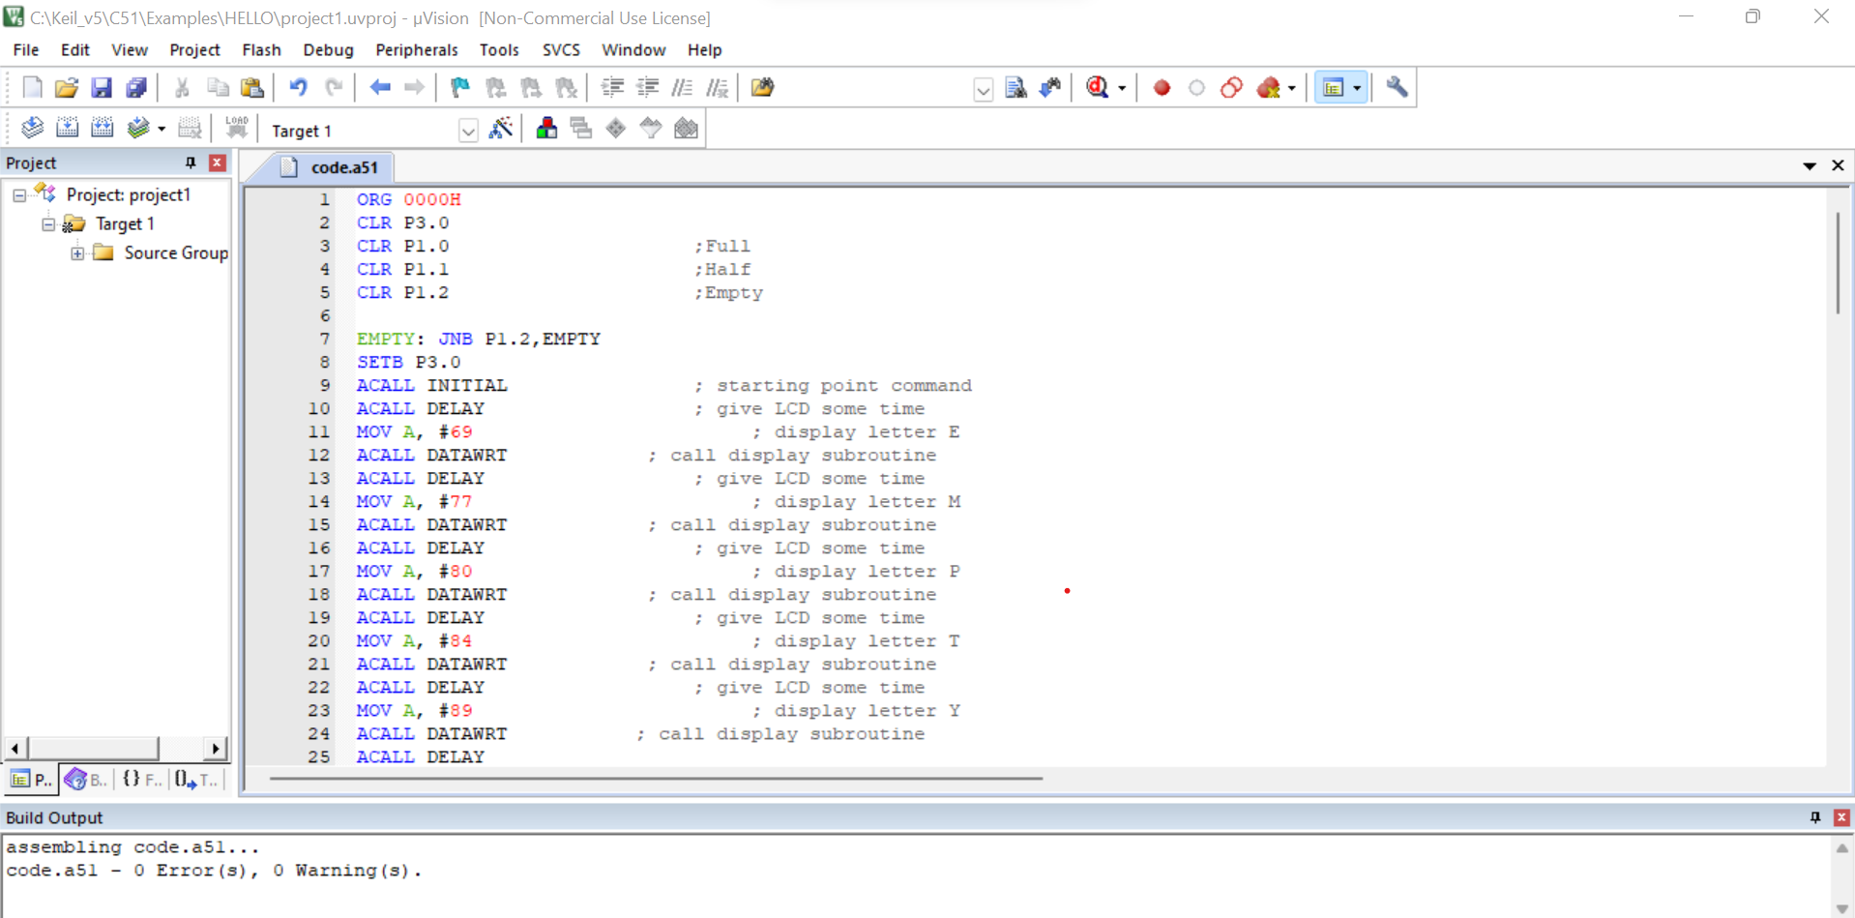

**Hex file:**

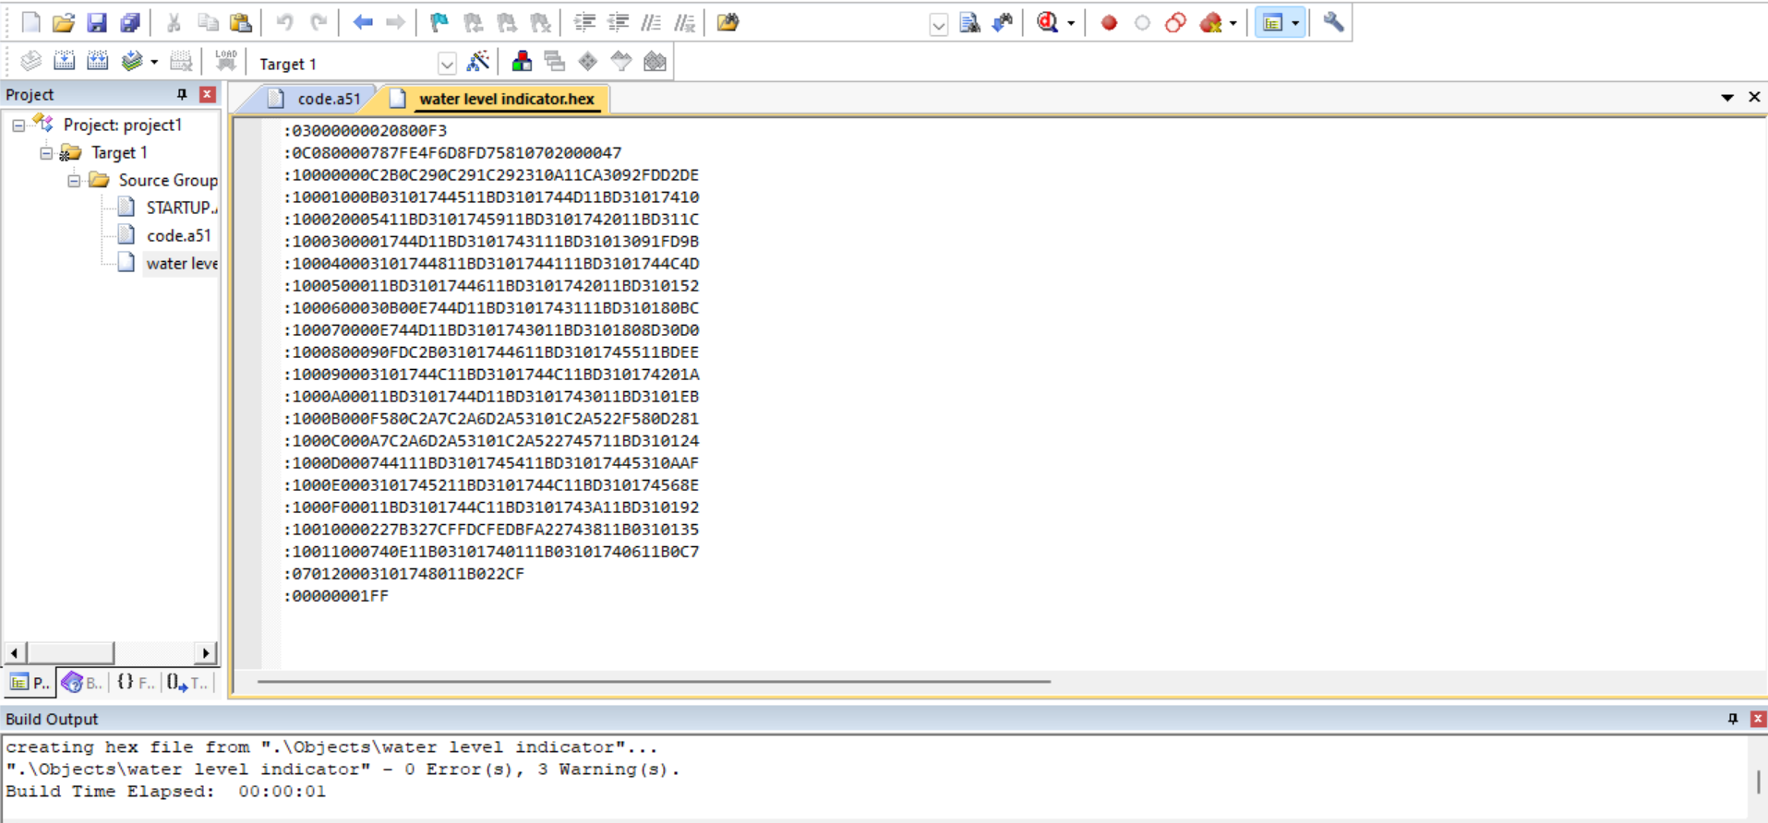

**CHAPTER 4**

**HARDWARE**

**COMPONENTS USED:**

### A diagram of a chip Description automatically generated8051 MC

8051 microcontroller is designed by Intel in 1981. It is an 8-bit microcontroller. It is built with 40 pins DIP (dual inline package), 4kb of ROM storage and 128 bytes of RAM storage, 2 16- bit timers. It consists of are four parallel 8-bit ports, which are programmable as well as addressable as per the requirement. An on-chip crystal oscillator is integrated in the microcontroller having crystal frequency of 12 MHz .The system bus connects all the support devices to the CPU. The system bus consists of an 8-bit data bus, a 16-bit address bus and bus control signals. All other devices like program memory, ports, data memory, serial interface, interrupt control, timers, and the CPU are all interfaced together through the system bus.

**BREADBOARD**

A breadboard, solderless breadboard, or protoboard is a construction base used to build semi-permanent prototypes of electronic circuits. Unlike a perfboard or stripboard, breadboards do not require soldering or destruction of tracks and are hence reusable. For this reason, breadboards are also popular with students and in technological education.

### LCD MONITOR

An LCD is an electronic display module that uses liquid crystal to produce a visible image. The 16×2 LCD display is a very basic module commonly used in DIYs and circuits. The 16×2 translates o a display 16 characters per line in 2 such lines. In this LCD each character is displayed in a 5×7 pixel matrix.

### RESISTOR – 10ohms

Resistors play a crucial role in various aspects of the circuit. Firstly, voltage dividers comprising resistors are often employed to scale down the voltage levels from sensors or other components, ensuring compatibility with the microcontroller's input range. Additionally, resistors are integral in setting reference voltages, determining current flow in different parts of the circuit, and protecting components from excessive currents.

**RNPN -TRANSISTORS**

Transistors are commonly used for signal amplification and switching tasks within the circuit. In particular, transistors may be employed to amplify the weak signals generated by sensors, ensuring that these signals are robust enough for accurate processing by the microcontroller. Moreover, transistors can act as switches to control the flow of current to various components, allowing for the implementation of alert systems or the activation of pumps in response to specific water level thresholds. Additionally, transistors contribute to the stability and efficiency of the circuit by regulating the current and voltage levels, enhancing the overall performance and reliability of the water level monitoring system.

**RELAY**

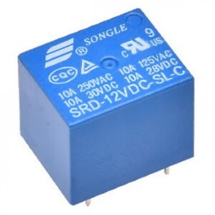

A power relay module is an electrical switch that is operated by an electromagnet. The electromagnet is activated by a separate low-power signal from a micro controller. When activated, the electromagnet pulls to either open or close an electrical circuit.

**HARDWARE ANALYSIS:**

• Connect LCD to 8051 microcontroller in port 2. Now connect P3.0, P1.2, P1.1, P1.0 to relay, empty, half and full respectively.

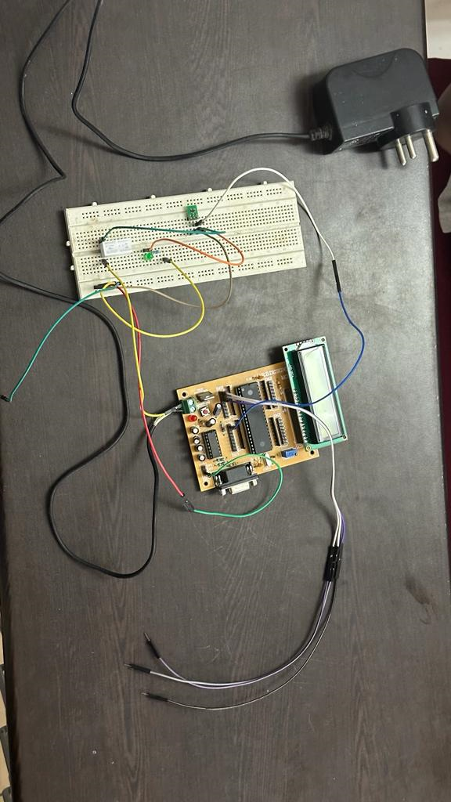

• Display ‘EMPTY’ if the there is no water in the tank

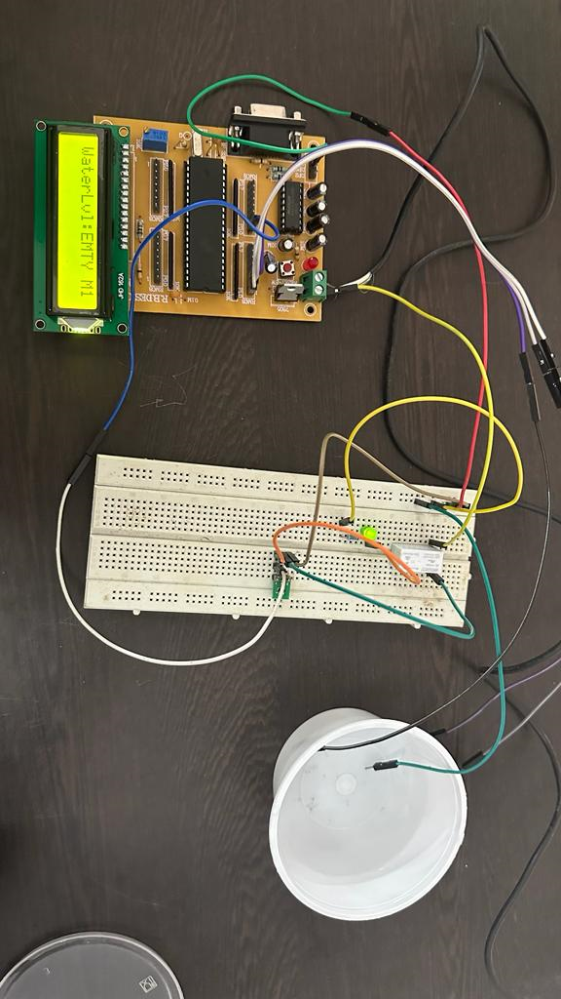

• Display ‘HALF’ if the tank is half full

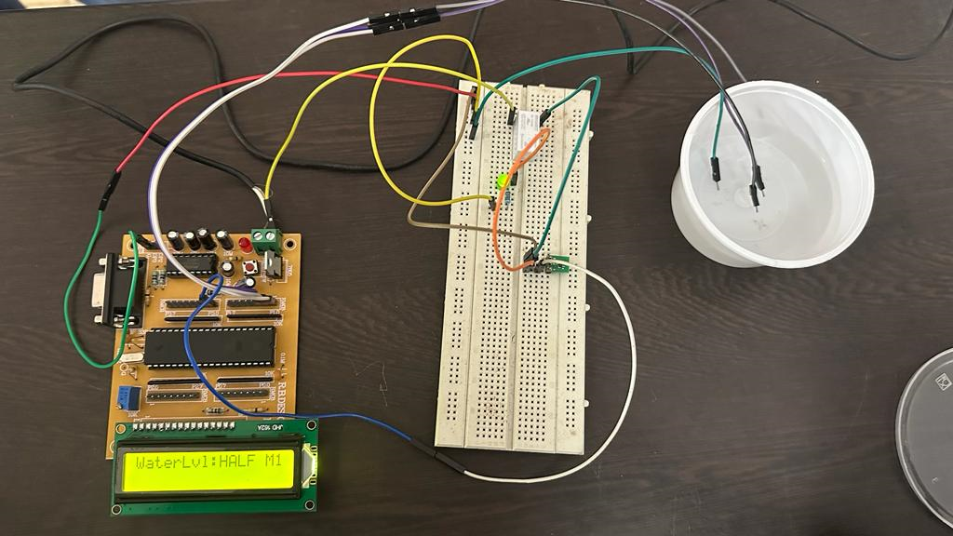

• Display ‘FULL’ if the tank is full

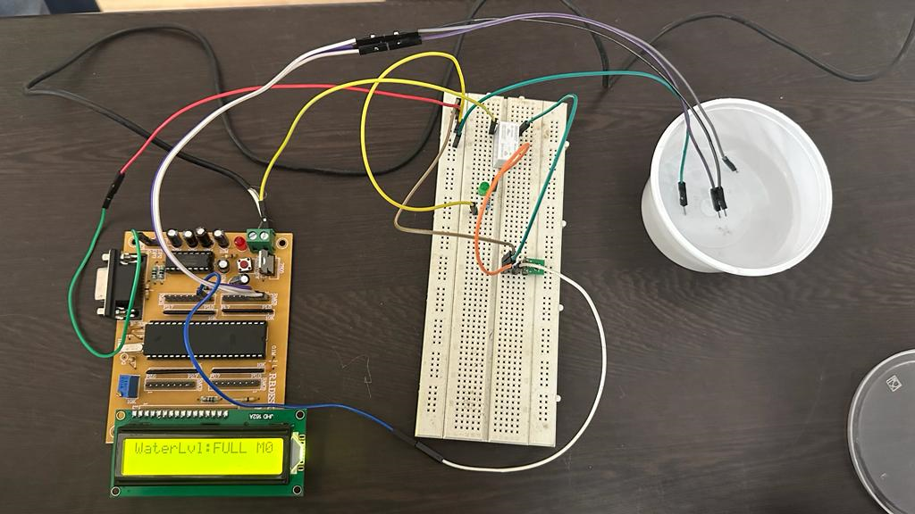

**CONCLUSION AND FUTURE SCOPE:**

Nowadays water is being wasted in many ways and wastage due to overflowing of tanks is a major contributor for this. Thus, Water Tank Monitoring System helps to reduce the wastage of water due to overflowing by automatically turning off the pump when the water level in the tank reaches a threshold limit. Proposed system can also be enhanced by monitoring the entire activity through an app. An application is developed to help the users turn on the pump as shown in the experimental setup and off the pump when tank is empty automatically.

The future scope for the water level monitoring system using an 8051 microcontroller includes integrating wireless communication for remote monitoring, implementing data logging and analytics, exploring cloud integration, developing a dedicated mobile app, incorporating sensor fusion for improved accuracy, automating control actions, enhancing energy efficiency with renewable sources, integrating machine learning for predictive analysis, improving user interfaces, and expanding the system for community or industrial-scale applications. These enhancements aim to provide more advanced features, scalability, and sustainability for comprehensive water management.

**BIBLIOGRAPHY:**

1. Konstantinos Loizou, Eftichios Koutroulis, Dimitrios Zalikas and Georgios Liontas, A Low-cost Capacitive Sensor for Water Level Monitoring in Large-Scale Storage Tanks, Â©2015 IEEE.

2. L.A. Gama-Moreno, A. Corralejo, A. Ramirez-Molina, J. A. Torres- Rangel, C. Martinez-Hernandez and M.A. Juarez, A Design of a Water Tanks Monitoring System Based on Mobile Devices, 2016 International Conference on Mechatronics, Electronics and Automotive Engineering, Proc. of IEEE,Â© 2016 IEEE.

3. Beza Negash Getu and Hussain A. Attia,Automatic Water Level Sensor and Controller System, Â©2016 IEEE.

4. Shrenika R M , Swati S Chikmath , Dr. Ravi Kumar A V , Mrs. Divyashree Y V and Mrs. Roopa K Swamy, Non-Contact Water Level Monitoring System Implemented using LabVIEW and Arduino, 2017 International Conference on Recent Advances in Electronics and Communication Technology, Â© 2017 IEEE.

**ACKNOWLEDGEMENT:**

We wish to express our sincere thanks and deep sense of gratitude to our project guide, **Dr. A.Sivasubramanian**, for his consistent encouragement and valuable guidance offered to us in a pleasant manner throughout the course of the project work.

We also take this opportunity to thank all the faculty of the institution for their support and their wisdom imparted to us throughout the course.

We thank our parents, family, and friends for bearing with us throughout the course of our project and for the opportunity they provided us in undergoing this course in such a prestigious institution.

**ABSTRACT**

Most of the people in residential areas face the problem of running out of water and overflow of water in water tanks due to excess supply of water. It becomes difficult for users to judge the level of water in water tanks, due to which at times of need users may run out of water. Even when the pump is turned on users will not realize when the water tank is filled which may result in overflow. Water tank monitoring system is used to sort out the issues associated with water tank.

It is also possible to check the level of the water using sensor so that whenever the water goes below certain threshold limit, a notification is sent to user through the android application and user needs to turn on the pump. Also when there is overflow of water in water tank it uses sensor to detect the water level so that if the water level goes above certain limit the pump gets turned off automatically. This system prevents wastage of water.